Going to Hear Them Roar

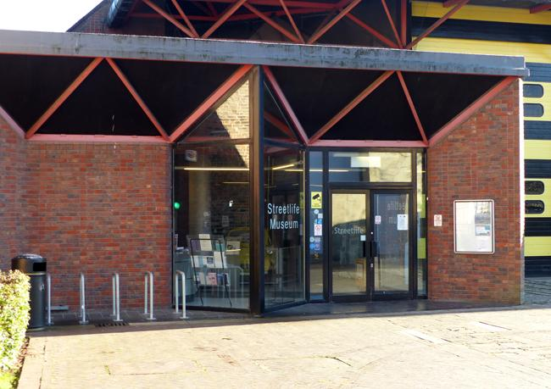
Streetlife Museum is a building that displays lots of different historical vehicles in Hull

ARCADE is a community producing company

Streetlife Museum & ARCADE are putting on an event for women & non-binary folk

The event is called Hear Them Roar

Hear Them Roar is on Thursday 28th March 2024, at 6pm - 9pm

I am going to go with my friends

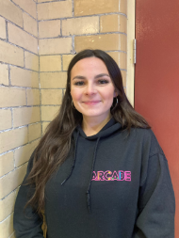
When I arrive I will be welcomed by staff and given directions to the different activities

There will be live music from musicians from The Warren

There will be speeches by Karen Ellis and Sarah Hicks

There will be live theatre extracts from Middle Child Hull’s latest piece ‘Baby, He Loves You’

I can watch if I want too

There will be artists running feminist activities

I can choose which activities I want to do

The activities include: making a protest sign, listening to music, and looking around the exhibition created by The Warren about Women that Inspire us

If I want, I can take a picture with my creations

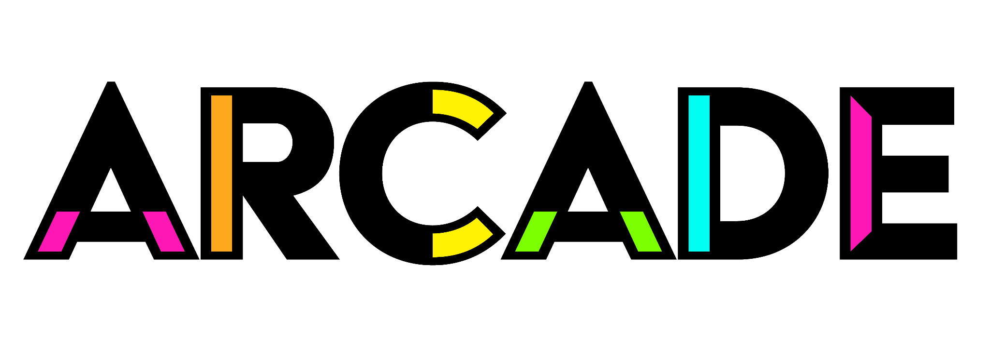
If I need help there are staff that can help

They wear black hoodies that say ‘ARCADE’ on the front and ‘TEAM’ on the back in pink

There will be busy spaces and quiet spaces

If I want to, I can go to the chill-out space and relax. This space will be quieter with seats

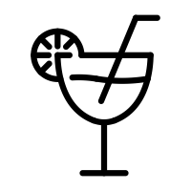
I can have an alcoholic or non-alcoholic drink and sit down in the bar area

There will be a wheelchair accessible toilet

The event will finish at 9:00pm

I can leave the event any time I want

I might like to say goodbye to people I have met

At the end of the event I will go home

