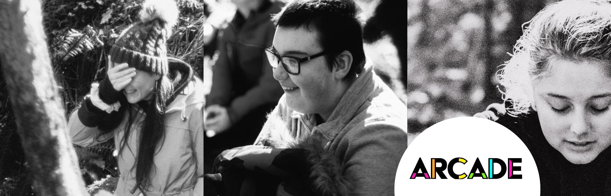

Lead Artist Call Out - Creative Youth Music Programme

Contract Type
Freelance, Fee of £3375 with contract renewal on a termly basis. This breaks down as the following:

14 weekly sessions @ £225 a day
1 day of prep for the term @ £225 a day

In addition to this, we are willing to cover the cost of petrol for the right candidate to and from the sessions @ .45p per mile and up to a 45 mile radius from Scarborough.

About Us
ARCADE is a charitable community producing company based in Scarborough and Bridlington, led by Rach Drew and Sophie Drury-Bradey. We think everyone is creative and we believe culture belongs to everyone. We are proud to be part of the Arts Council England National Portfolio.
​
Our mission is to: ​
​
- Enable our community and artists to co-create high quality cultural experiences which catalyse positive social change
- Activate confidence and agency through creativity in children & young people
- Inspire and enable working class women & girls to reach their full potential

​We do this through creative projects, workshops, shows, festivals and events. See more on our website here.

About the project
In 2023 we were honoured to be awarded funding from the Youth Music Catalyser Fund. This is supporting us to deliver a 3 year programme of regular creative music sessions with and for students at Scarborough Pupil Referral Unit beginning April 2024. We need a multiskilled artist with a strong youth music facilitation background to lead these sessions.
Young people at PRU face multiple barriers when it comes to accessing music and creative programmes, as they have been excluded from mainstream school and PRU does not offer music as part of their curriculum. Many of the PRU students have experienced trauma, poverty, substance abuse, and the criminal justice and care system either themselves directly or within their immediate family.
Our sessions will allow students to work with professional artists who are skilled at facilitating in accordance with the unique and challenging needs of this vulnerable cohort.
The students will have the chance to express themselves through musical play and will work towards writing, recording and producing their own music/songs. There will be multiple opportunities throughout the programme for young people to share & perform their work to invited and public audiences in celebration and gig style events.

Responsibilities

- Work regularly with the PRU youth group
- Lead on session planning taking a steer from the young people
- Deliver the sessions with support from an Emerging Artist
- Work with the ARCADE team to support and mentor the Emerging artist on the job
- Feed into evaluation
- Work in a trauma informed way
- Make the sessions engaging
- Maintain regular communications with the Lead Producer, updating them of your planning and decision making
- Be punctual to sessions
- Build rapport with students
- Maintain a professional standard when liaising with project partners
- To increase skills & confidence in young people's music abilities
- Adhere to safeguarding policies

Artist Specifications
- Full Enhanced DBS dated within the last 3 years/On the update system
- 2 References
- Previous high quality experience of working in a Pupil Referral Unit setting
- Ability to drive & access to own vehicle
- Strong knowledge of music production
- Can provide own equipment
- Ability to play at least one instrument to a good standard
- Songwriting skills
- Music composition skills
- Knowledge of different music genres
- Experience of working in a trauma informed way
- Ability to collaborate
- Proven experience mentoring/developing other artists
- Ability to work specific themes & stimulus into sessions through engaging and fun methods

Timeline
The Spring term will run on Friday mornings 9:30am - 12:30pm between April and July. The sessions will take place in multiple locations to be confirmed closer to the time. The artist must be available on all of the following dates:

Friday 12th April 9:30am - 12:30pm
Friday 19th April 9:30am - 12:30pm
Friday 26th April 9:30am - 12:30pm
Friday 3rd May 9:30am - 12:30pm
Friday 10th May 9:30am - 12:30pm
Friday 17th May 9:30am - 12:30pm
Friday 24th May 9:30 - 12:30pm
Friday 7th June 9:30am - 12:30pm
Friday 14th June 9:30am - 12:30pm
Friday 21st June 9:30am - 12:30pm
Friday 28th June 9:30am - 12:30pm
Friday 5th July 9:30am - 12:30pm
Friday 12th July 9:30am - 12:30pm
Friday 19th July 9:30am - 12:30pm

Artists will be expected to join planning, debrief & check in meetings where appropriate.

Recruitment Process
Please send a CV & covering letter to info@hello-arcade.com.

First round application closing date: 9am Friday 1st March
First round Notifications: Week Commencing 4th March 2024

Second Round Interviews: Wednesday 13th & Thursday 14th March 2024
Second Round Notifications: Week Commencing 18th March 2024

Access

We welcome applications from people of all backgrounds and walks of life, and we aim to be an inclusive and supportive team to work with.
Please let us know if you require any support to apply, for instance:
- If you prefer this document in an alternative format please email shan@hello-arcade.com
- If you prefer to apply for the role in a different format (to that which is described above) please let us know by emailing shan@hello-arcade.com to notify us of what works for you and we will do our best to accommodate this
If you make it to the second round of the application process, we will ask you about any access requirements you may have in order to interview and we will do our best to support these.

