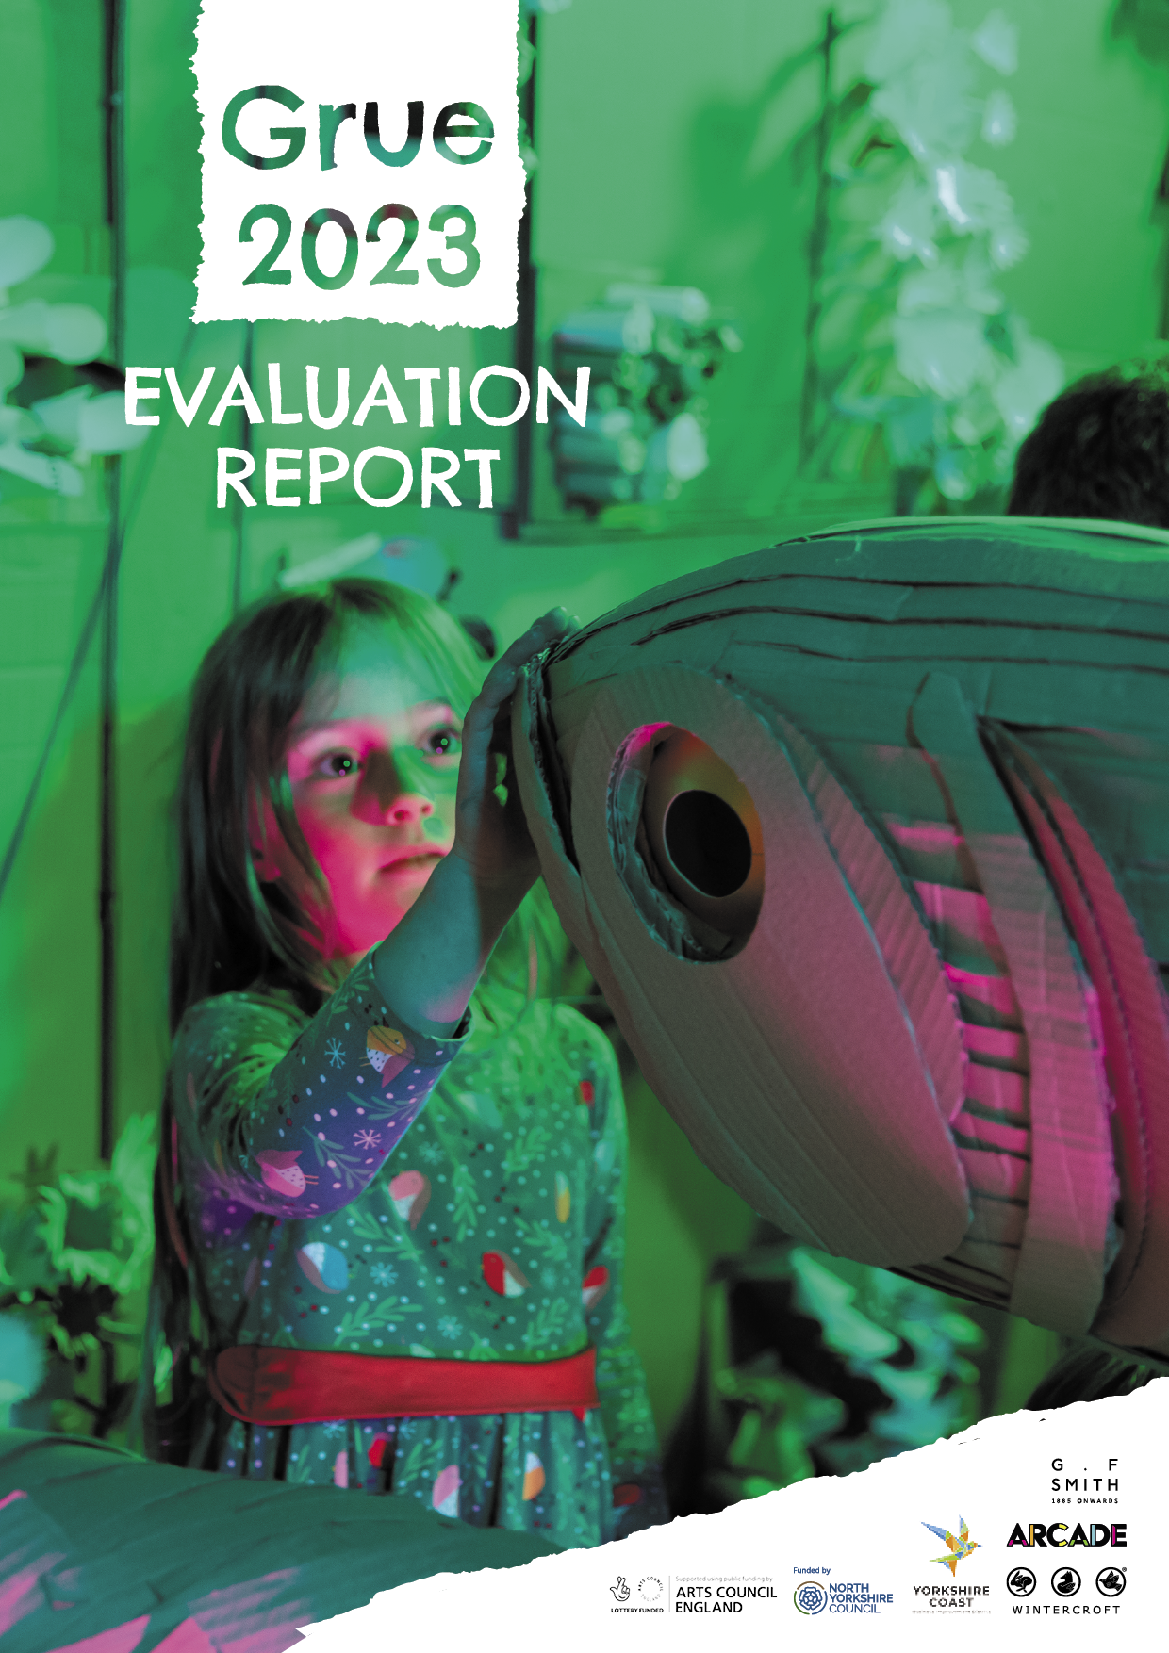

FANTASTICAL CARDBOARD ADVENTURE

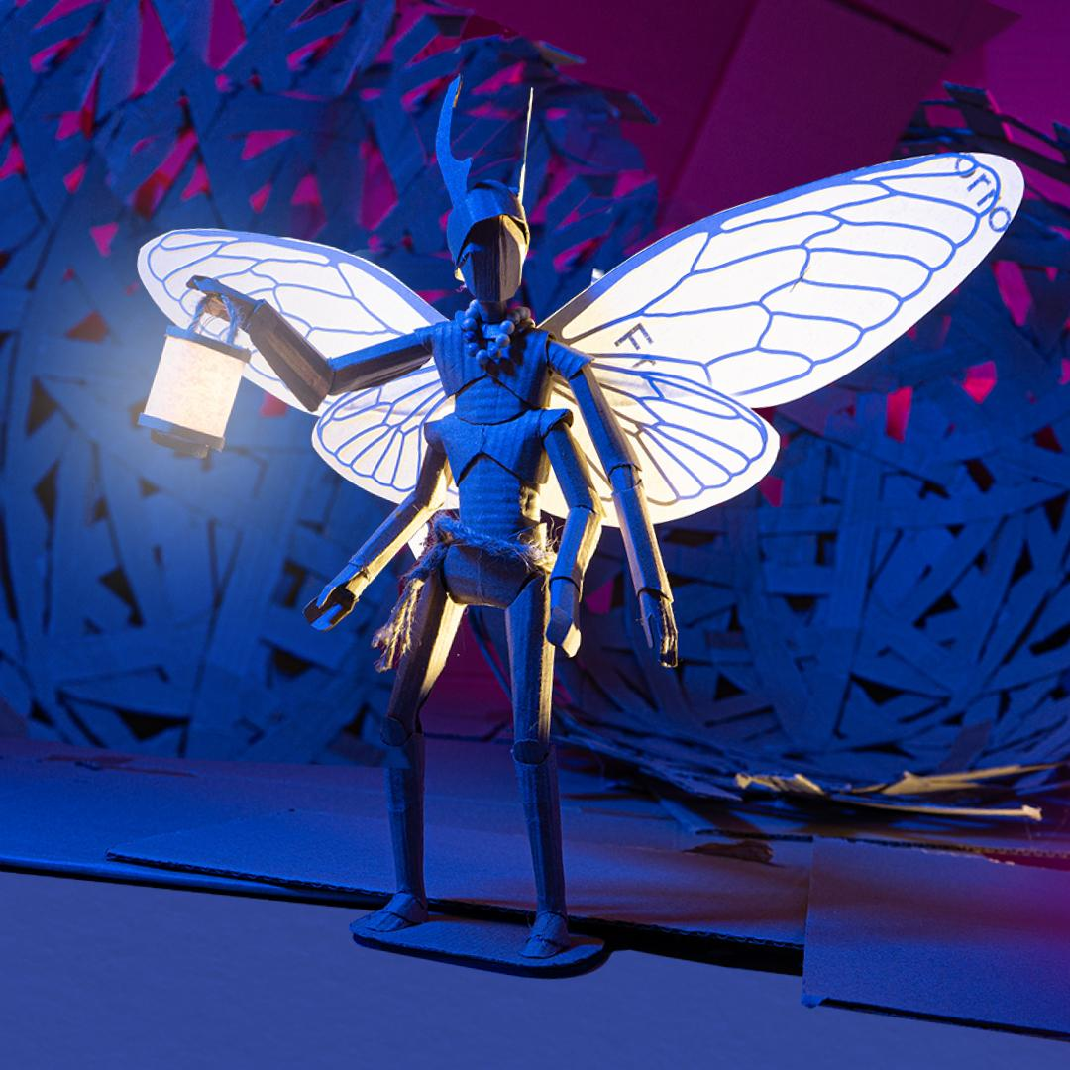Back for its third year, popular immersive installation, Grue by [Wintercroft](https://wintercroft.com/), returned in 2023. Built by our community and made entirely from recycled and repurposed materials, Grue was reached through a magical door on the top floor of [Scarborough Library](https://www.northyorks.gov.uk/leisure-tourism-and-culture/libraries/local-libraries/scarborough-library).

Grue invited audiences to step into a fantastical world and explore a series of enchanting landscapes. Travelling through dense forest and across icy regions on an important mission; to help our Librarian document a special creature - the Inkthief.

With live actors, puppets and interaction, Grue 23 was our biggest and most ambitious yet.

This report includes the results of evaluation, which were taken from 353 questionnaires completed on site. This constitutes 20% of our audience, this high sample size giving us confidence in our results.

HEADLINES

Grue was attended by **1667 people.**

**522 people** attended free community workshops over 25 hours – equating to approximately **2000 hours** of time. 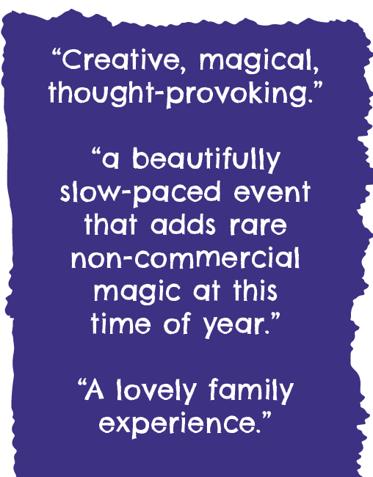

Press coverage included; the **front page of the Yorkshire Post**, a feature on **BBC Look North** (approx. 4 million viewers), and multiple features on local/regional Radio, press and social media.

**31 creative freelancers** worked on Grue.

98.6% of visitors rated Grue as Good or Excellent.

98.8% of visitors said they would recommend Grue to a friend.

AUDIENCE

Grue has had its best year yet for media success, with the project and partners becoming well known locally.

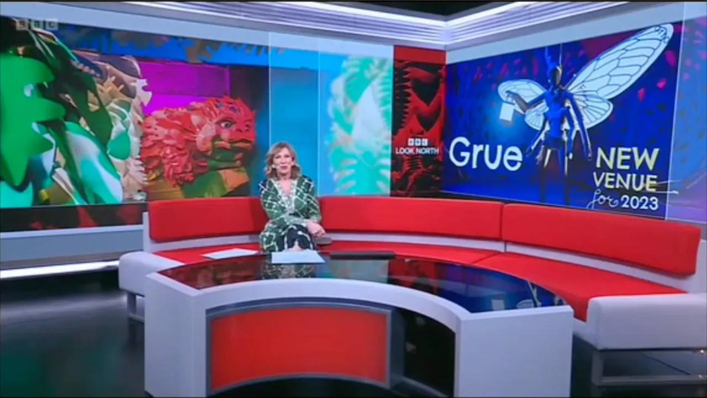

Print newspapers also have social media posts which we cannot get the figures from.

[**Look North**](https://youtu.be/vh5MIvuAAJ0) (watched by 4 million+)

**Yorkshire Post** (print circulation 10634) - front page image seen by many more

**York Press** (Circulation 7674)

**Scarborough News** (Circulation 3783)

[**Creative Boom**](https://www.creativeboom.com/news/grue/) (8000)

**This is the Coast** (1647)

**BBC Radio York** (58000)

**BBC Radio Sheffield** (171000)

**81% said they came into town just to see Grue.** It would be reasonable to suggest that these people went on to spend money at local businesses.

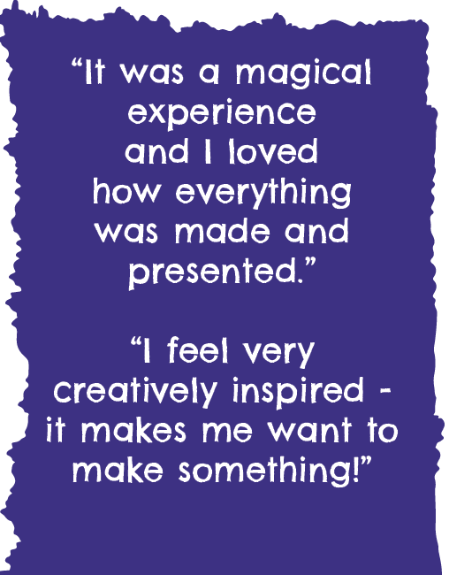

TICKETS

Entry to Grue was Pay What You Can, with a suggested donation of **£4 per ticket.**

**93.23%** of those who booked a Pay What You Can ticket decided to pay something for their ticket at the time of booking.

Grue had 23 people buy an additional Pay It Forward ticket.

Grue made **£3693 in ticket sales.**

13% of bookers live in postcodes which are in the bottom 10% of LSOAs in England.

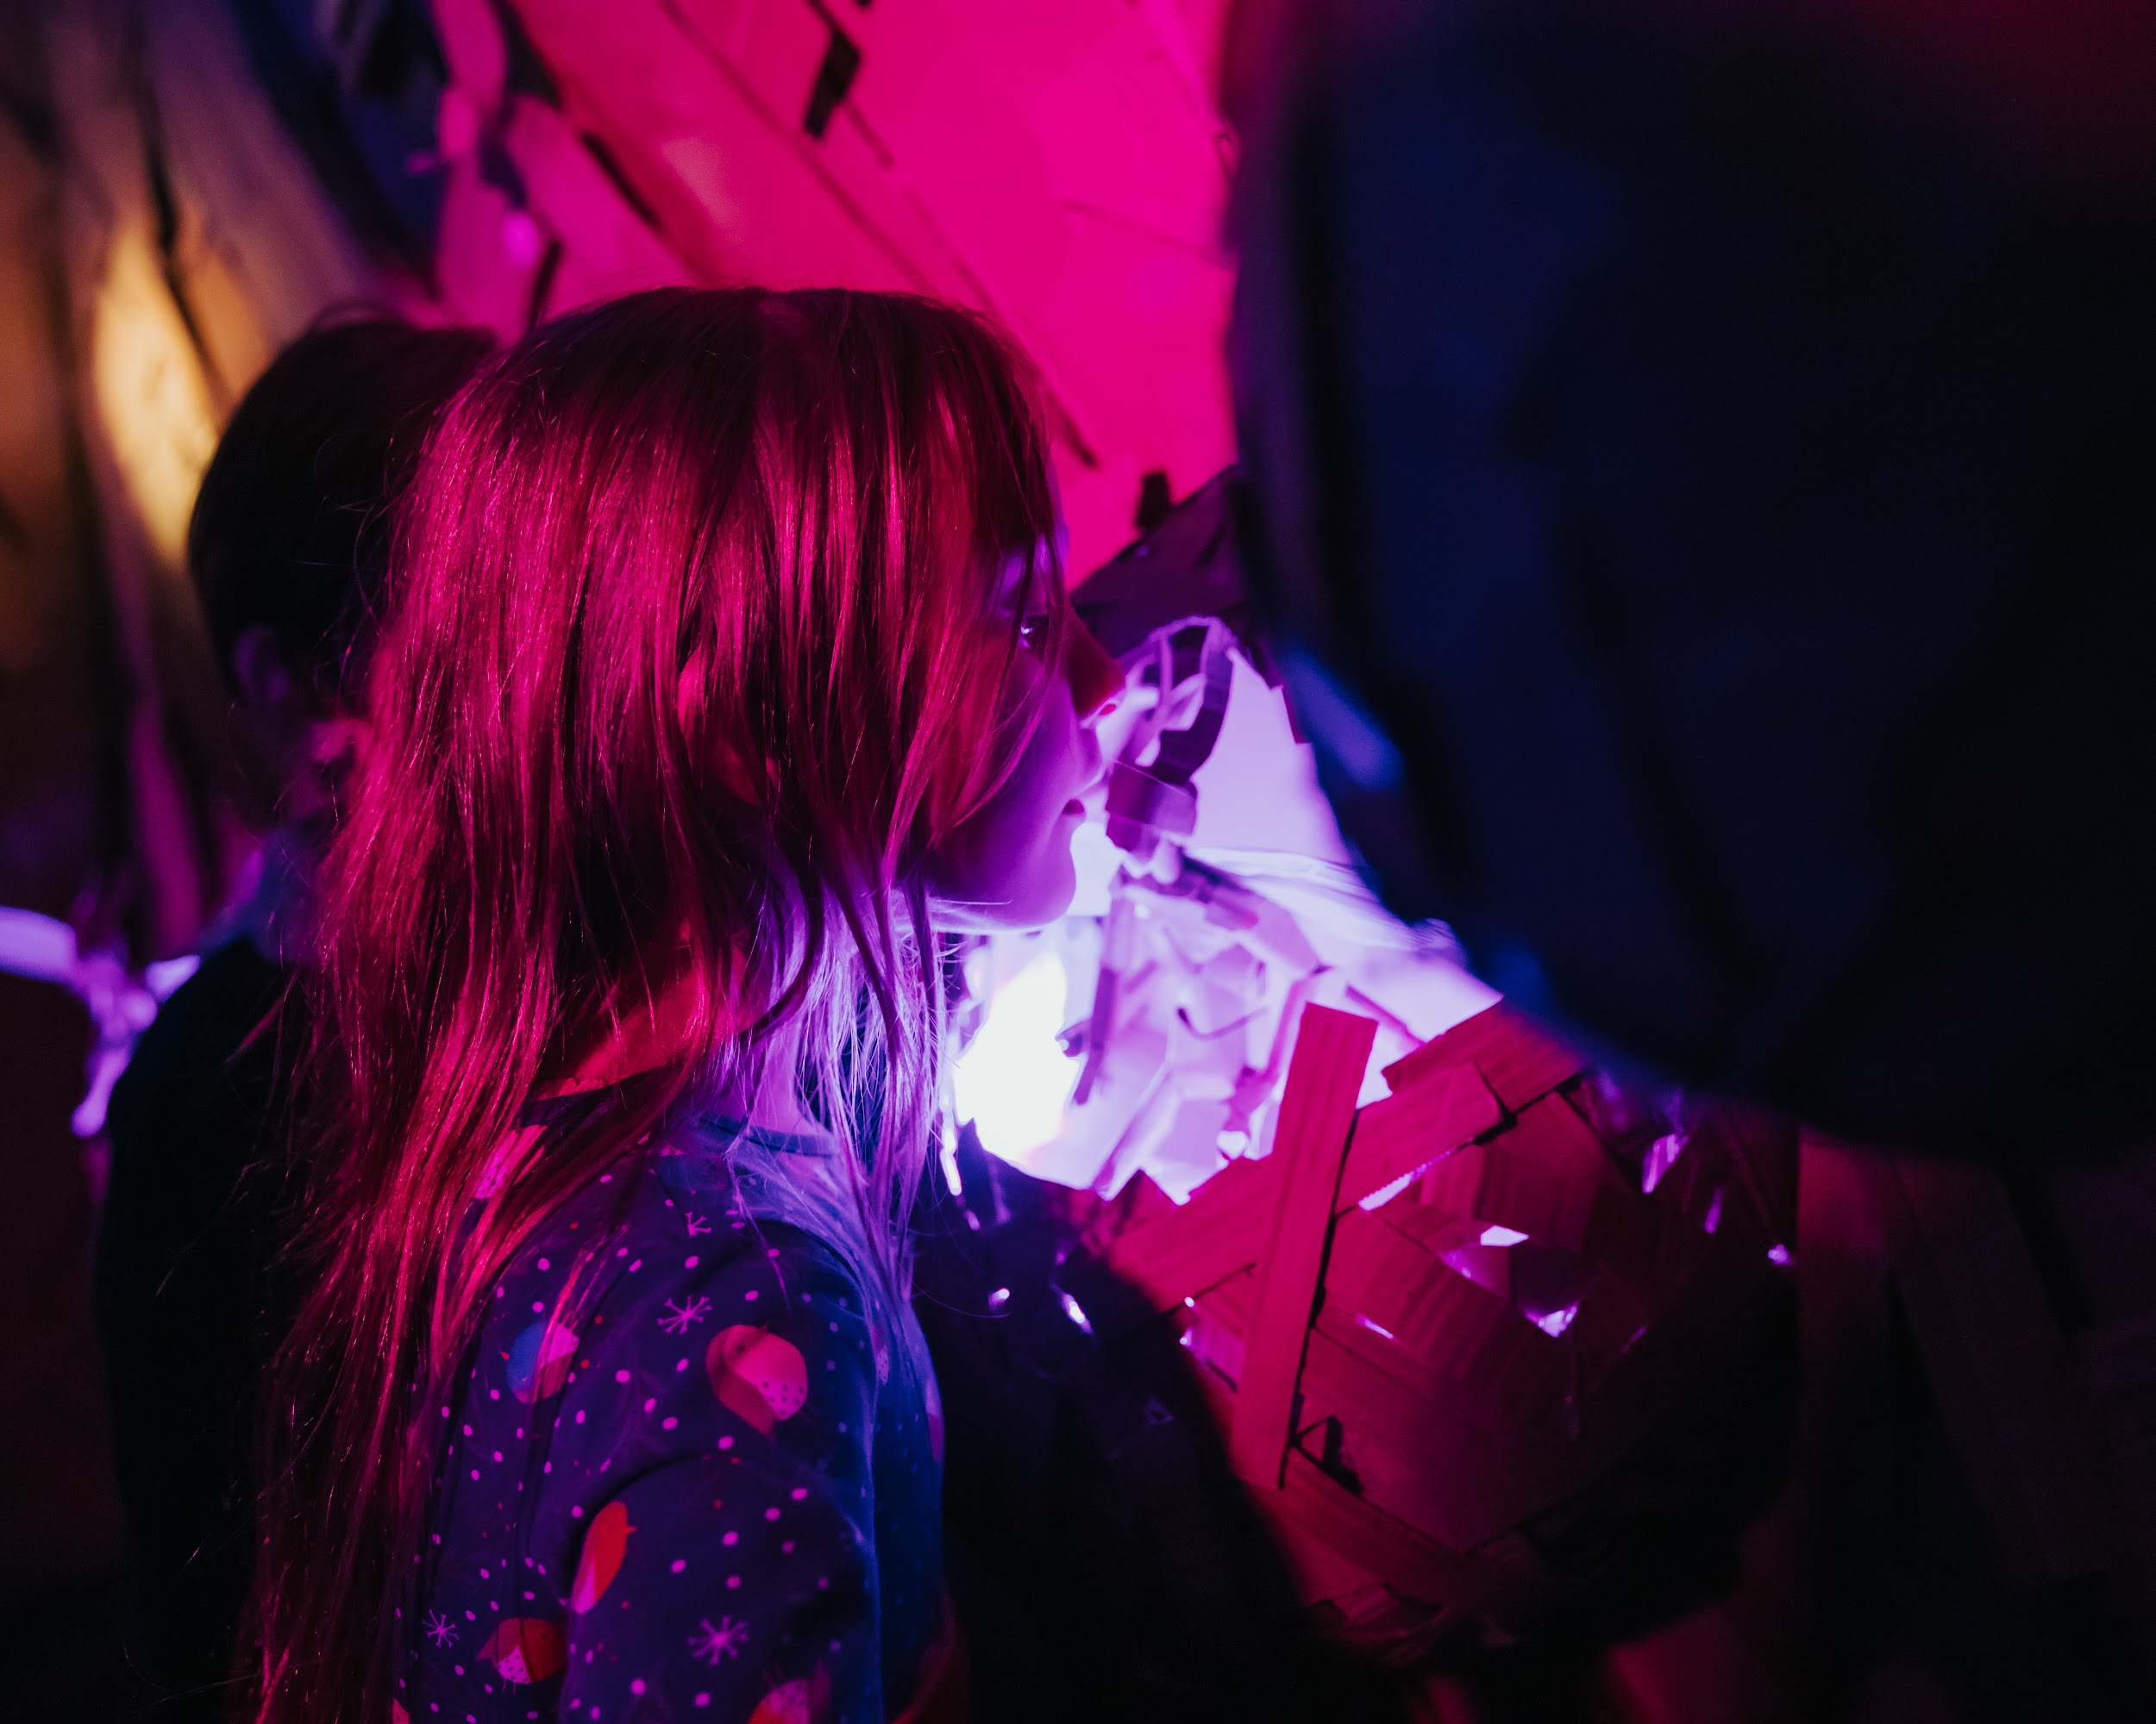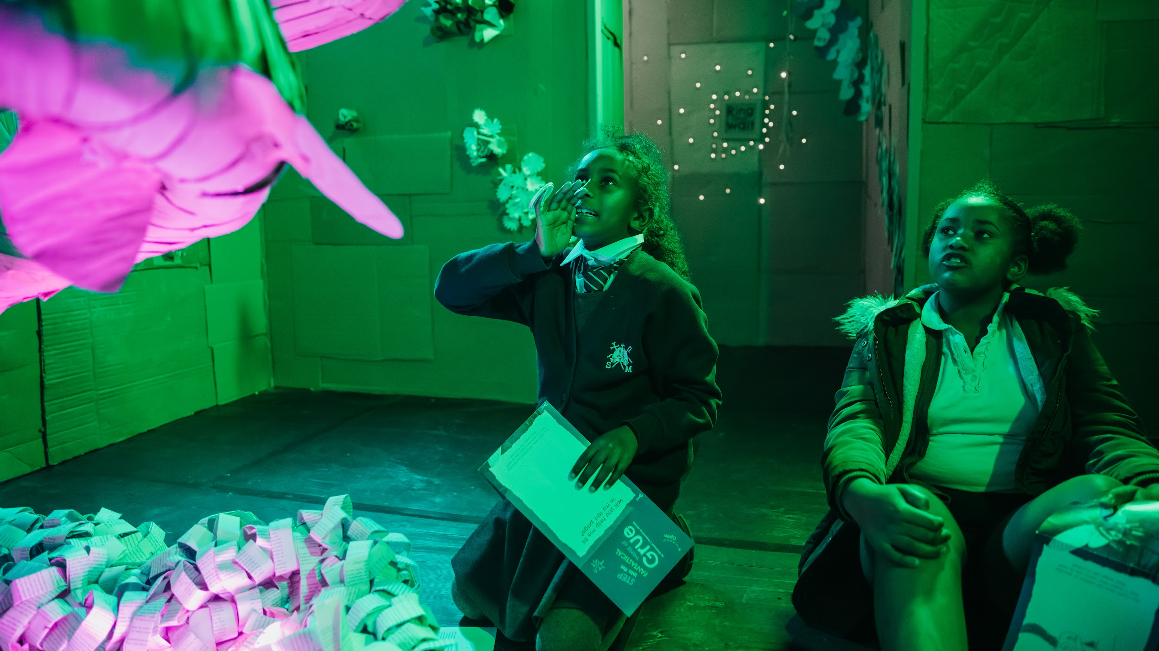

SCHOOL INVOLVEMENT

St Martin’s School had workshops and a visit to Grue, and was featured on Look North. Teachers commented on how brilliant and beneficial they felt the work was for the children.

LOCAL BUY IN

Grue’s audience in 2023 was made up of 78.9% Scarborough residents, 16.6% from the wider region, and 4.5% national. Grue pulls in audiences from further afield, with an organised group trip from Glasgow.

Being based in the Library in central Scarborough meant we were able to make the most of footfall and some of our build sessions were attended by upwards of 90 people per session - that’s a lot of people in 4.5 hours!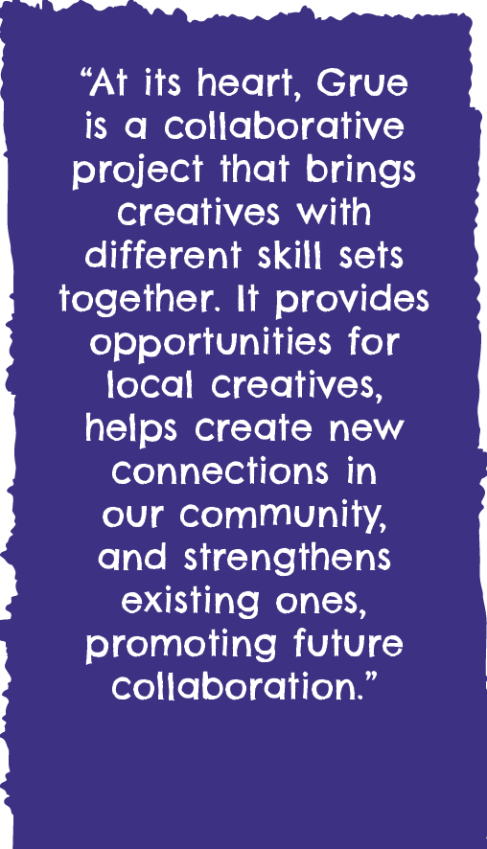

Grue means a lot to local residents who help to build and return year on year. This year we even hosted a birthday party.

We also spent more time in the community this year, running workshops with Rainbows, Brownies and Guides, as well as at the local college, primary schools and centres for adults with learning difficulties.

The project contributed towards the programme for Scarborough Fair’s Scarborough Lights festival.

LIBRARY VISITORS INCREASE:

December 2022 - **8800 visitors**

December 2023 - **11298 visitors**

Total increase: **2498**

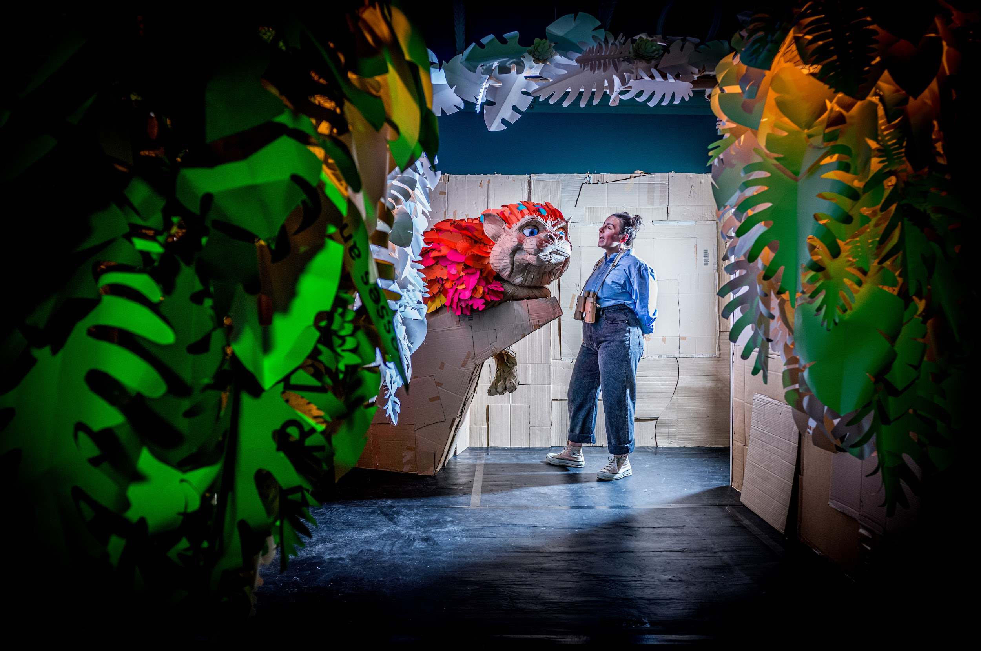FUNDING

Grue was funded by Yorkshire Coast BID and Arts Council England, with support in kind from North Yorkshire Council and Scarborough Library.

EVALUATION

Stats from our questionnaire included:

**81%** of visitors came into town especially to 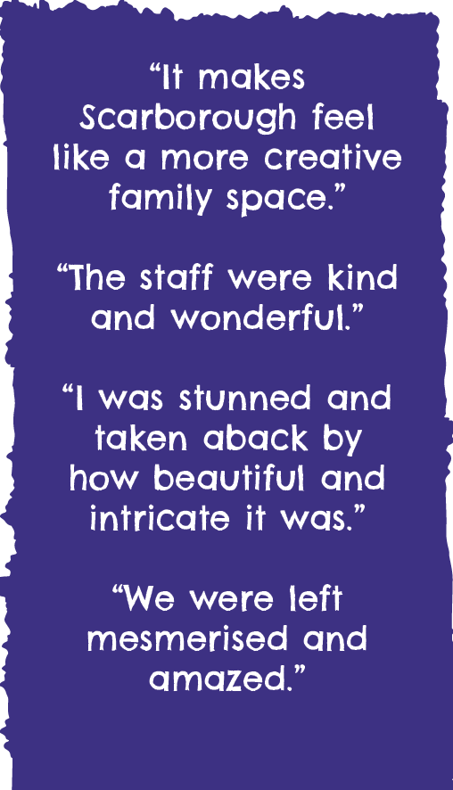see Grue (**1356 people**).

**63%** of visitors said Grue had made them think or feel differently about the environment or climate change.

**46%** of visitors had never been to an ARCADE event before.

**9%** of visitors said that Grue was their first experience of an arts/cultural event.

